# San Jose State University

# Department of Electrical Engineering

# EE250-02

Fall 2019

# Midterm 1

# Duration: 1 hour

##### SOLUTION

# October 2, 2019

## This test consists of four problems.

CLOSED BOOK

### Use of one sheet (double sided) of formula is allowed.

### Last Name:

**First Name:**

### Student ID:

### 

|  |  |
| --- | --- |
| **Problem** | **Grade** |
| 1 |  |
| 2 |  |
| 3 |  |
| 4 |  |
| Total |  |

Good Luck!

#### Prof. Kamali

**Problem #1 [6 points]:** Five balls with numbers one through five written on them have been placed in an urn. Two balls are picked randomly. What is the probability that the numbers on the two balls differ by one?

**Solution:**

There are $\left(\begin{matrix}5 \\ 2\end{matrix}\right)=\frac{5!}{\left(5-2\right)!2!}=10$ ways to choose two balls from a set of five balls. In four of these ways, the numbers differ by one; (1,2), (2,3), (3,4), (4,5). Therefore, the probability will be $\frac{4}{10}=0.4$.

**Problem #2 [8 points]:** A discrete random variable is known to have three outcomes of 0, 1, and 2. Through extensive testing, the expectation and variance of this random variable are estimated to be $E\left[X\right]=1$ and $Var\left[X\right]=\frac{1}{2}$. Find and *plot* the probability mass function (pmf) of this random variable.

**Solution:**

Let us denote by $p_{0}$, $p_{1}$, $p_{2}$ the probabilities of 0, 1, and 2.

$$E\left[X\right]=\sum_{k=0}^{2}{kp_{k}}=p_{1}+2p_{2}=1$$

$$Var\left[X\right]=E\left[X^{2}\right]-{\left(E\left[X\right]\right)}^{2}=\sum_{k=0}^{2}{k^{2}p_{k}}=p_{1}+4p_{2}-1=\frac{1}{2}$$

$$\left\{\begin{matrix}p_{1}+2p_{2}=1 \\ p_{1}+4p_{2}=\frac{3}{2}\end{matrix}\right.$$

$$p_{1}=\frac{1}{2} p_{2}=\frac{1}{4}$$

Finally

$$\sum_{k=0}^{2}{p_{k}}=1$$

And thus $p_{0}=\frac{1}{4}$

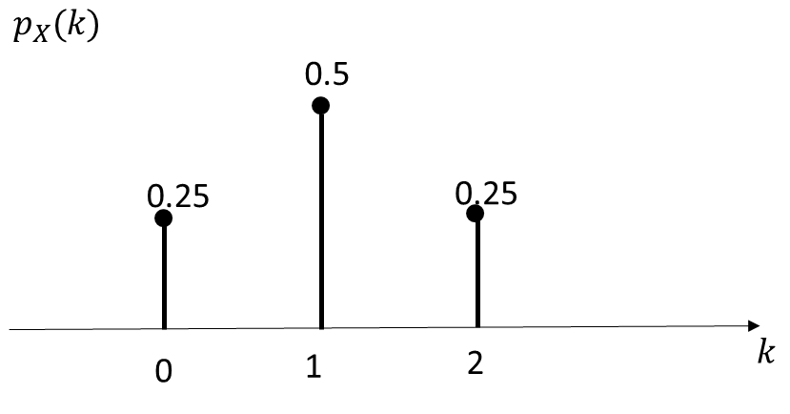

**Problem #3 [6 points]:** The number of customers arriving in a bank follows a Poisson random variable with the average rate of two customers per minute. Find the probability that more than two customers arrive in thirty seconds.

**Solution:**

$P\left[N=k\right]=e^{-α}\frac{α^{k}}{k!}$ $k=0,1,2,…$

Average in thirty seconds $α=0.5×2=1$

$$P\left[N>2\right]=1-\left(P\left[N=0\right]+P\left[N=1\right]+P[N=2]\right)$$

$$P\left[N>2\right]=1-\left(e^{-1}\frac{1}{0!}+e^{-1}\frac{1}{1!}+e^{-1}\frac{1}{2!}\right)=1-2.5e^{-1}=0.08$$

**Problem #4 [10 points]:** The probability density function (pdf) of a continuous random variable is given as follows.

$f_{X}(x)=\left\{\begin{matrix}\frac{1}{2} & 0<x<2 \\ 0 & elsewhere\end{matrix}\right.$

1. Find $P[X<1]$**.**
2. Find and *plot* the conditonal cdf $F_{X}(x|X<1)$ and conditional pdf $f_{X}(x|X<1)$.

**Solution:**

$P\left[X<1\right]=\int_{0}^{1}{f_{X}\left(x\right)dx=}\int_{0}^{1}{\frac{1}{2}dx=\frac{1}{2}}$

$F_{X}\left(x | X<1\right)=P\left[X≤x | X<1\right]=\frac{P[X≤x,X<1]}{P[X<1]}$

If $0<x<1$, then $P\left[X≤x,X<1\right]=P\left[X≤x\right]=\int_{0}^{x}{f_{X}\left(x\right)dx=}\int_{0}^{x}{\frac{1}{2}dx=\frac{x}{2}}$

If $1<x<2$, then $P\left[X≤x,X<1\right]=P\left[X<1\right]=\int_{0}^{1}{f_{X}\left(x\right)dx=}\int_{0}^{1}{\frac{1}{2}dx=\frac{1}{2}}$

Therefore

$F_{X}\left(x | X<1\right)=\frac{P[X≤x,X<1]}{P[X<1]}=\left\{\begin{matrix}x & 0<x<1 \\ 1 & x>1\end{matrix}\right.$

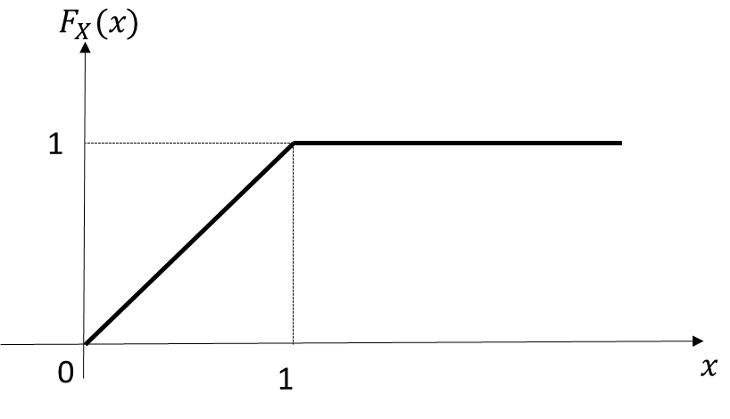

$f_{X}\left(x | X<1\right)=\frac{d}{dx}F_{X}\left(x | X<1\right)=1$ for $0<x<1$.

